# Goal 1: Create Fat-JAR on Laptop and run JavaSparkPi on Cluster

## Fat-JAR creation:

gradle fatJarWithTests

task fatJarWithTests(type: Jar) {

baseName = project.name + '-all-with-tests'

from { configurations.testCompile.collect { it.isDirectory() ? it : zipTree(it) } }

from sourceSets.test.output

with jar

}

## Command from example working

dcos spark run --submit-args='-Dspark.mesos.coarse=true --driver-cores 1 --driver-memory 1024M --class org.apache.spark.examples.SparkPi hdfs://hdfs/spark-examples/spark-examples_2.10-1.4.0-SNAPSHOT.jar 30'



## Command from Fat-JAR not working

dcos spark run --submit-args='-Dspark.mesos.coarse=true --driver-cores 1 --driver-memory 1024M --class com.zuehlke.shmack.sparkjobs.tutorials.JavaSparkPi hdfs://hdfs/libs/sparkjobs-all-with-tests-1.0-SNAPSHOT.jar 30'



### Where is the “Why”? Where is the Log?

This is all ;-(   


Request by chat:

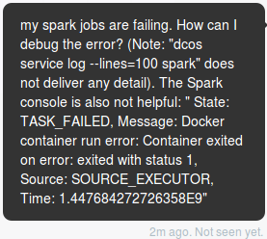

Solution:



🡪

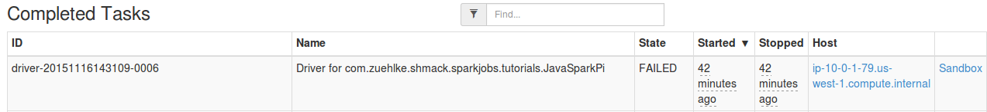

* Click on “sandbox”

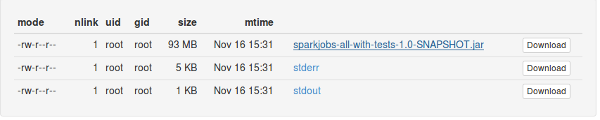

Stderr shows the problem:

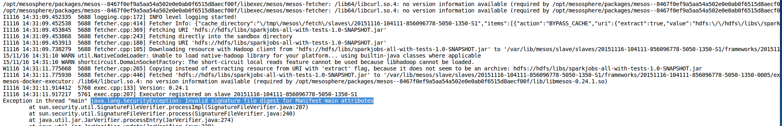

java.lang.SecurityException: Invalid signature file digest for Manifest main attributes

### Why is the manifest defective?

# Goal 2: Run WordCount on Cluster